Marburg Philipps-Universität IWU 2026
귀국보고서
1. Preparation & Arrival
Travel Route: Arrived in Barcelona on December 31st, then traveled overland through France and Switzerland. I reached Frankfurt on January 9th and moved to Marburg on January 10th via the RE train.
Key Insight: The university-provided Deutschland-Ticket (valid Oct 2025 – Mar 2026) and DAAD Insurance (covers January) are excellent benefits. Future participants should consider arriving in Germany earlier to explore cities like Cologne or Düsseldorf using these resources.

2. Academic Curriculum
German Language Course: The course was highly practical and focused on situational communication. Key topics included basics like the alphabet and introductions, shopping for clothes, family descriptions, and ordering at cafes or restaurants. The role-playing and Bingo activities using numbers (1–100) were particularly effective for learning essential expressions for daily travel.
Microbiology Lab: Regarding antibiotic resistance, we conducted experiments on E. coli to test its sensitivity to various antibiotics and the antimicrobial properties of natural substances like ginger and garlic. In the photosynthesis study, we investigated how light intensity affects microorganisms. We confirmed that while light is necessary, excessive intensity causes stress and eventually inhibits the photosynthetic process.
International Discussion: The theme was climate change and the potential for terraforming as a response to human extinction risks. I participated in the debate as an opponent of terraforming, engaging in thought-provoking discussions with students from diverse global backgrounds.

3. Student Life in Marburg
Cost Management: For groceries, Penny, Aldi, and Lidl are recommended over Edeka for better value. For household items like frying pans or cutlery, Woolworth is the best option.
Cash & Laundry: Many shops in the Oberstadt (Old Town) and the dormitory laundry machines require cash or coins. Using a Travel Wallet at Deutsche Bank allowed for fee-free withdrawals.
Weather Advice: The wind chill during weekend tours is significant. Heavy winter gear such as padded jackets is essential for the Marburg winter.

4. Extracurricular Activities
Bundesliga Experience: I traveled to Mainz to watch a football match. While the atmosphere was incredible and tickets were affordable at approximately 20 euros, one should be mindful of the frequent Deutsche Bahn (DB) delays when returning to Marburg late at night.
Weekend Travel: I visited Luxembourg using the student ID card (Deutschland-Ticket) with no extra charge. It is a 5–6 hour trip by regional train, making it a perfect cost-free destination for a 2-day excursion.

5. Summary
The Marburg IWU program was an enriching 2-week experience that successfully balanced academic learning with cultural exploration. From lab experiments to local football culture, every moment was an opportunity for growth. It was a truly fulfilling time that exceeded my expectations.

1st Weekend Trips: Marburg | 2nd Weekend Trips: Heidelberg
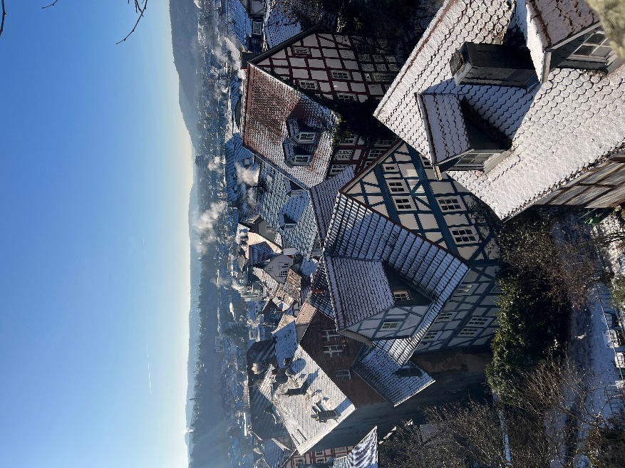 | 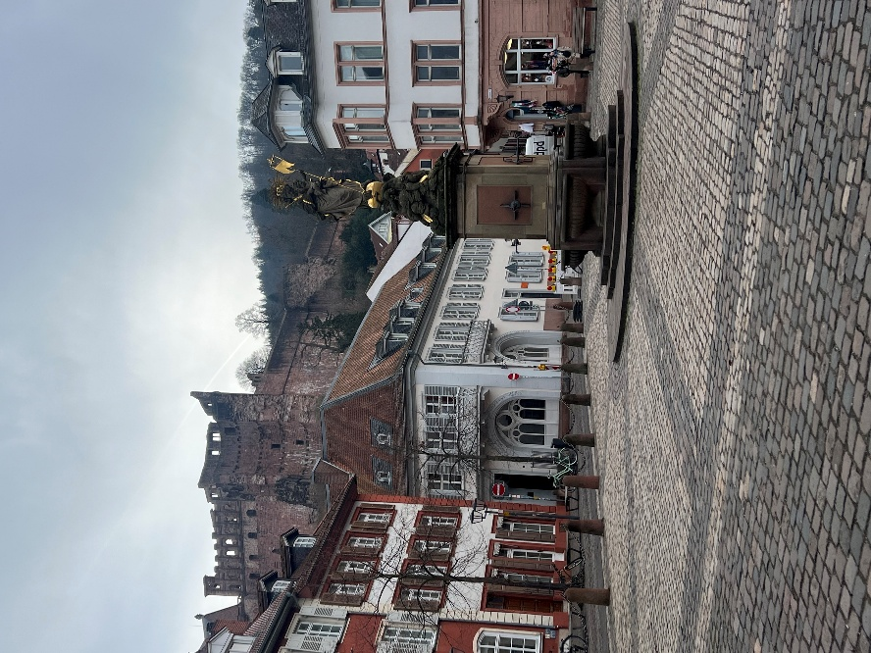
Intensive German Language Course | Microbiology Seminar Course
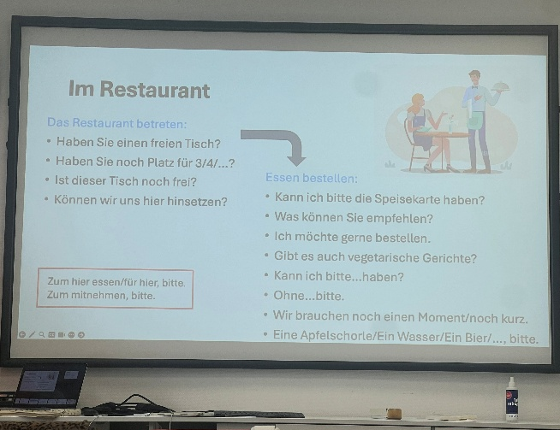 | 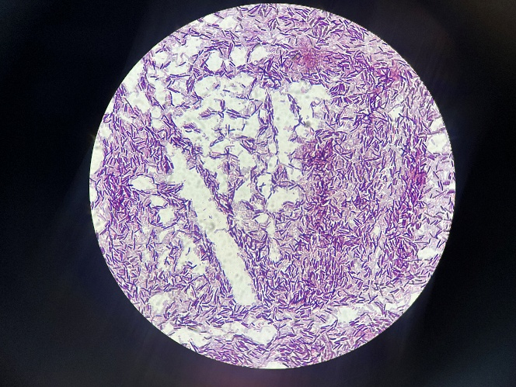
Weekend Solo Trip: Luxembourg | 

